Case Study: Strengthening Marketing Impact for A Christmas Carol at The Hanover Theatre

Introduction
The annual production of A Christmas Carol remains one of the strongest seasonal traditions at the Hanover Theatre, drawing unusually large audiences from Worcester and surrounding communities. Nonetheless, its legacy and strong attendance patterns continue to pose a recurring challenge to the theatre in terms of maintaining growth, optimizing revenue, and strengthening long-term engagement in increasingly competitive holiday entertainment markets. This case study analyzes several years of data from the theatre, including ACC buyer behavior, promotional performance, postcard conversions, email analytics, city-level demand, and performance-level ticket sales, to understand current audience trends and areas for optimization. Through interpretation of the data and reflection on personal insights throughout analysis, I aim to provide actionable recommendations grounded in real behavior rather than assumptions.

But one of the biggest takeaways from the project was how strategy has to be shaped by actual evidence and not tradition. A Christmas Carol has a nostalgic hold on many families, but its marketing performance varies significantly across channels, cities, and demographic segments. Through this analysis, I learned how digital behavior, price sensitivity, regional differences, and word-of-mouth influence the overall success and how these insights should shape the theatre’s marketing direction.

Methodology and Data Sources
This study is based on a comprehensive review of several sources provided by Hanover Theatre: the ACC email engagement data, marketing plans 2022 and 2023, buyer timelines, all-time buyer datasets, holiday demand by city, promotions performance, and seat-level sales data. The demographic information was also reviewed to assess age-based trends in engagement.
I have used Python, Pandas, and Matplotlib to perform basic cleaning and visualization to draw insights and have included respective graphs and charts for the strategies below.

Analysis & Interpretation of Findings
Strategy 1: Strengthening Digital & Social Media Presence
For each of the datasets analyzed, digital engagement proved the strongest and most consistent driver of interest. The theatre’s website and email campaigns demonstrate heavy activity during the October–December window, as do its social media pages. Yet, despite this high engagement, the theatre’s marketing budget remains disproportionately invested in traditional media formats.

This was one of the very first insights that jumped out at me, a mismatch between consumer behavior and budget allocation. The 2022 ACC marketing plan revealed that television, print, and miscellaneous traditional channels ate up most of the spending, while email, paid social media, and re-targeting received very little investment. That's a problem because digital channels are where families and young adults seek show times, watch videos, engage in holiday content, and make last-minute buying decisions.
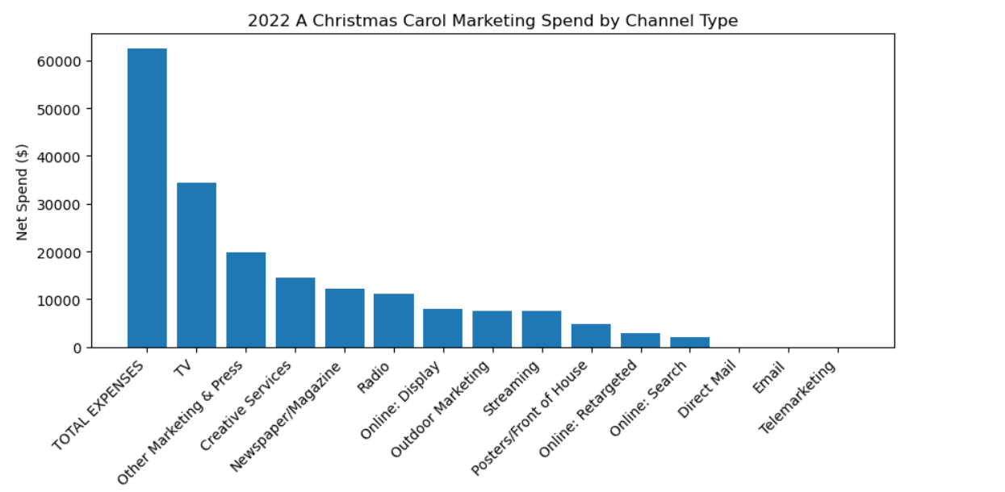
[Figure 1: Marketing Spend by Channel]

Digital marketing importance is further reinforced by e-mail performance data. The e-mails have achieved a very high open rate in most cases, between 40% and 55%. Click-through activity increases dramatically closer to the dates of performance. By looking at these numbers, I felt it is critical for the theatre to keep up the cadence of communication throughout, instead of relying on late-season digital pushes. Dips in CTR and revenue mid-campaign suggest that fresh creative or stronger segmentation could help improve performance.

Additionally, website age demographics data revealed a meaningful presence of users between 18 and 34 visiting the site. Though not as dominant as the 35-54 group, younger adults make up a formidable segment exploring content online. This surprised me because it goes against the assumption that the typical audience base for theater is hugely older. I realized that the biggest issue isn't interest, it is conversion. And digital strategy is the bridge between those two.

These digital insights have also made me realize how the theatre needs to shift from traditional announcements to digital storytelling. Theater could benefit from behind-the-scenes videos, for instance, short cast interviews, rehearsal clips, interactive Instagram stories, and regular weekly Reels/TikToks. These are not expensive to make but align extremely well with where audience already engage.

This strategy is most important because strengthening digital presence directly supports late-season decision making, expands reach to young online audiences, and better aligns marketing spend with actual consumer behavior.

Strategy 2: Boost Word-Of-Mouth & Promotion Effectiveness
The second key strategy that emerges from the data involves improving word-of-mouth (WOM) through emphasizing the most effective promotions, not the most numerous. Although promotions remain an important tool, the data reveals that not all promotions create meaningful value.

For example, postcard data suggests that the “Adult” pricing types result in the highest revenue among recipients of the postcard, followed by moderate discounts such as Cast50% and Subscriber pricing. Surprisingly, deep discounts (BOGO, Fezzwig, Chorus) return very low revenue and do not meaningfully influence buyer behavior.
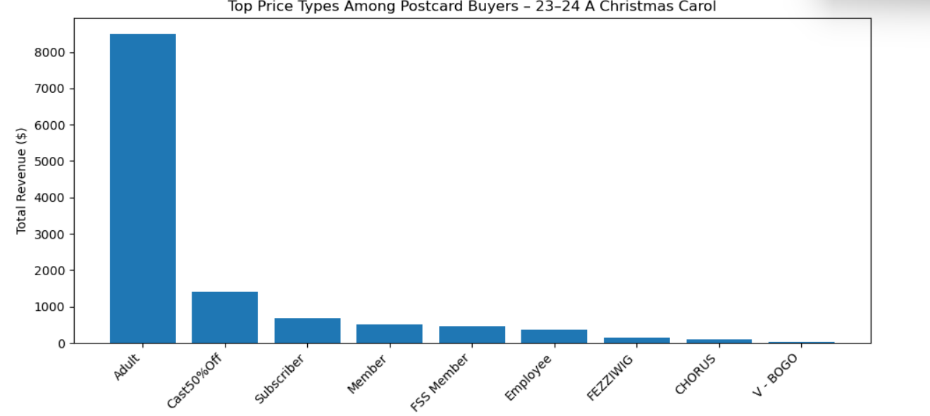
[Figure2: Postcard Price Type vs Performance]

What this showed me is that discounting must be used with precision. More importantly, buyers drawn by postcards appear to value the experience more than the discount. This insight made me reconsider assumptions about theatre discounting, I had originally thought postcards worked because of lower prices, but clearly the emotional pull and tradition-based messaging are so much more powerful.

This was corroborated in the data set ACC Promotions All-Time. The top revenue-driving promotions were membership-driven, including "Member" and "FSS Member," with the close second being the "Cheer" promotion. The promotion code "Cheer" is broad, simple, and seasonally themed, which likely explains why it spreads easily through word-of-mouth. Meanwhile, subscriber and corporate discounts contribute minimal revenue and add complexity without meaningful return.

As I reviewed these findings, I realized the theatre does not need more promotions, it needs clearer and fewer promotions that align with buyer behavior. The best word of mouth strategies should revolve around easy-to-share deals, emotionally resonant messaging, and offers that reflect holiday identity.
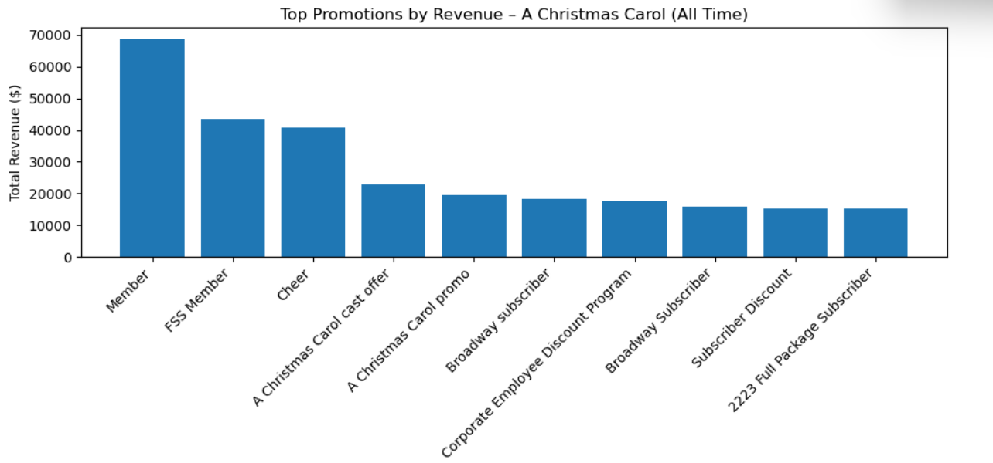
[Figure3: Promotions All−Time vs Revenue]

The city-level demand for holidays also validates a WOM focused strategy Worcester, Shrewsbury, and Auburn are consistently the top drivers of holiday show tickets and revenue, which indicates high levels of natural communication networks. Other cities with a strong and moderate demand represent fertile ground for WOM expansion through partnerships, local ads, and referral-based promotions.

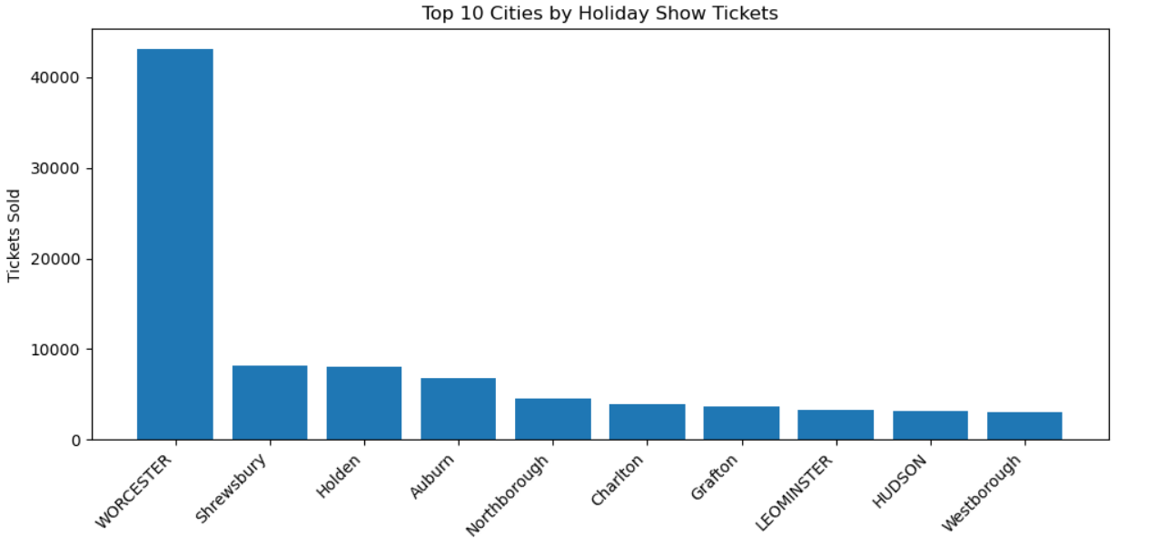
[Figure 4: Holiday Show Demand by City ]
This review changed my perception of promotional strategy completely. The data shows that WOM spreads best where communities have pre-existing traditions-and Hanover must build on that strength rather than trying to discount itself into new markets.

Strategy 3: Broader appeal to younger audiences

The third key strategy for the project is extending theater reach to younger adult audiences. This is an important strategy, but the data indicates its strength particularly when it supports the previous two strategies, mainly through a robust plan for digital engagement and targeted promotions.

Seat-level data for the 2023–2024 season showed that weekday performances, especially those in early to mid-December, continually underperformed against weekend evening shows. Early-season performances represent ideal opportunities to engage younger audiences who tend to have flexible schedules, lower price expectations, and higher openness to spontaneous decision-making.

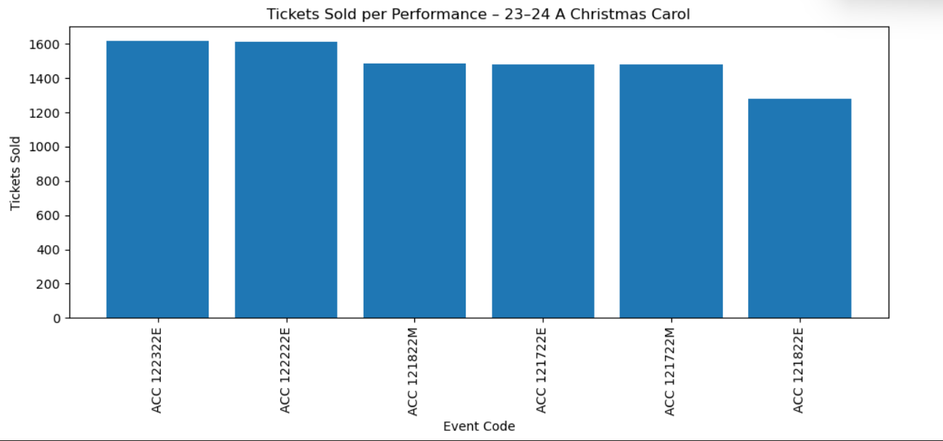
[Figure 5: Tickets Sold per Performance]

After considering a scatter plot of ticket vs revenue, it became clear that the shows with low ticket counts and low revenue are precisely the ones that need youth-oriented outreach. They are not drawing in families, but could draw students and young adults with the proper messaging.

To better understand the geography of where younger audiences are, the ACC 16–24 Buyer dataset provided geographic insight. Worcester, Shrewsbury, and Auburn again showed up as top cities with younger buyers, areas that also contain universities or large young adult populations.
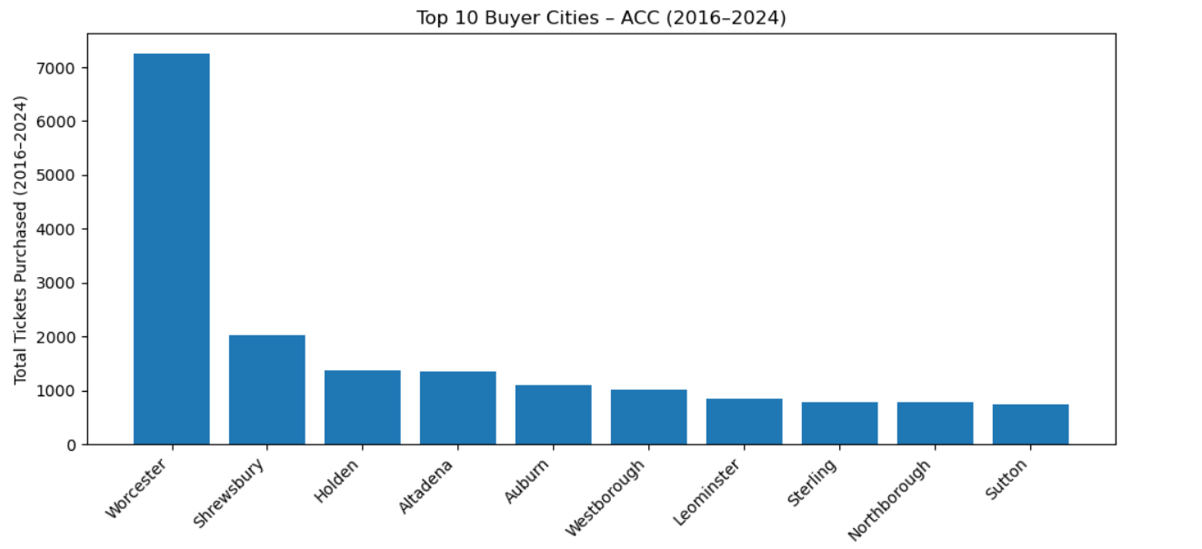
[Figure 6: ACC16–24BuyerGeography]

So far, this section of the analysis has reinforced to me that it's less a question of 'reimagining' theater and one more of practical and social access to audiences. Younger audiences' needs include:
- Clear and limited-time deals
- Accessible weekday shows
- Socially driven messaging
- Digital content with a personal touch
- Campus partnerships and student ambassadors

When these elements all come together, the theatre can fill lower-demand shows while building a new generation of holiday attendees.

Conclusion
By analyzing multi-year marketing and sales data from the Hanover Theatre, I have developed an appreciation for the complexity that exists in marketing a long-running holiday production like A Christmas Carol. What at first glance had appeared to be a rather straight-forward marketing challenge proved to be incredibly interconnected from digital behavior and pricing psychology to geographic trends and generational differences.

For me, the most important takeaway was how to align the marketing strategy with the real behavior of the audience. Digital engagement is high, digital marketing spend is low. There are a lot of promotions, but only a few really matter. Young audiences are active online, yet theater hasn't fully bridged the gap between curiosity and purchase.
Recommendations, in order of priority, based on this analysis are:
Shift budget and resources to digital and social media to ensure a consistent, storytelling-driven campaign throughout the season.

Leverage word-of-mouth via high-impact promotions that avoid complicated, low-performing discounts. Expand engagement efforts among the youth through strategic scheduling, campus outreach, and social-first content. The project really altered my perspective on arts marketing, It needs to be underpinned by data, emotional value, and community behavior in order to be effective. However, for a show as popular and long-standing as A Christmas Carol, improvements in digital presence, simplification of promotions, and engagement of younger demographics represent the most impactful ways to bolster attendance and build its success for the future.

References
Hanover Theatre. (2022). ACC Promotions All-Time. Internal dataset.
Hanover Theatre. (2023). Seats per Performance (ACC 23–24). Internal dataset.
Hanover Theatre. (2022). Holiday Shows by City. Internal dataset.
Hanover Theatre. (2022). ACC 2022 Email Data. Internal dataset.
Hanover Theatre. (2022). ACC All-Time Buyers. Internal dataset.
Hanover Theatre. (2022). ACC 2016–2024 Buyers. Internal dataset.
Hanover Theatre. (2022). Google Analytics Age Report. Internal analytics file.
Hanover Theatre. (2022–2023). ACC Marketing Plans. Internal planning documents.

